(a) | 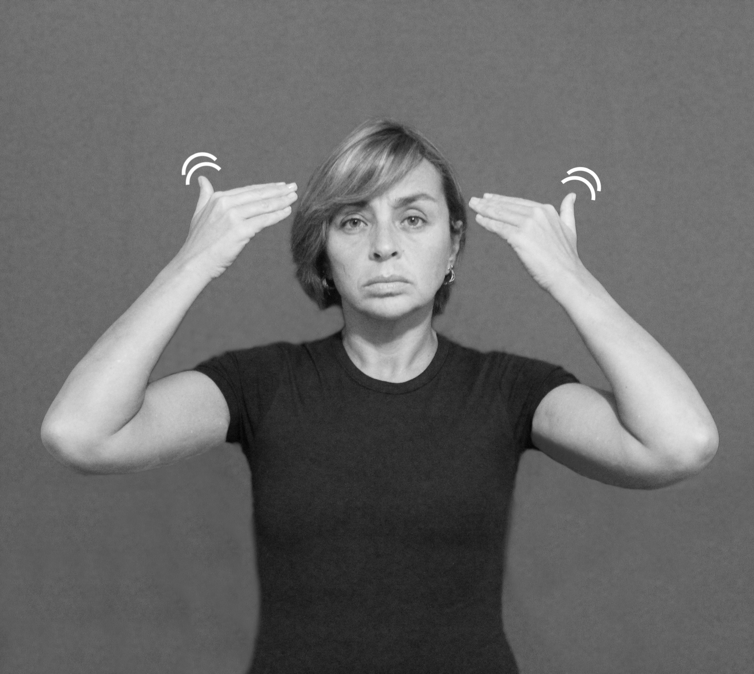  (b)
Figura (6) - ENTENDER

Segundo uma das colaboradoras surdas deste trabalho, pode-se usar a versão com duas mãos do sinal ENTENDER em perguntas nas quais esse sinal é enfatizado (ou intensificado) como em “Você entendeu mesmo?”. Casos como esse evidenciam que a categorização aqui descrita não é estanque e que, portanto, pode variar de acordo com o contexto em que o sinal foi usado.

