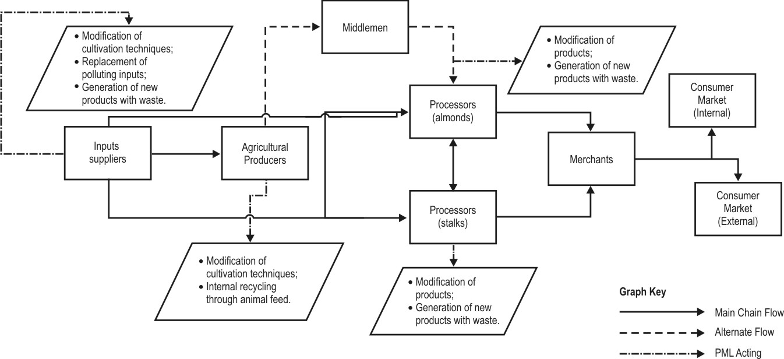

Picture 2: Suggestions for the preventive adoption of PML in the productive chain.
Source: Elaborated by the authors from the research data.

