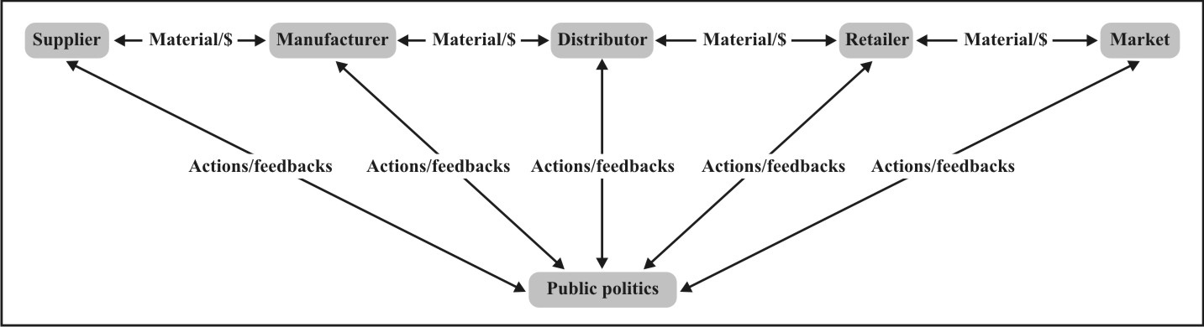

Picture 1: Generic productive chain.
Source: Adapted from Corrêa and Corrêa (2004, p. 116).

